Name: Indrayani Shinde

Roll No: A065

**Practical 2: Storage as a service using AWS**

Implement S3 for uploading file, video.

To create a bucket in S3, name the bucket and keep the default settings.

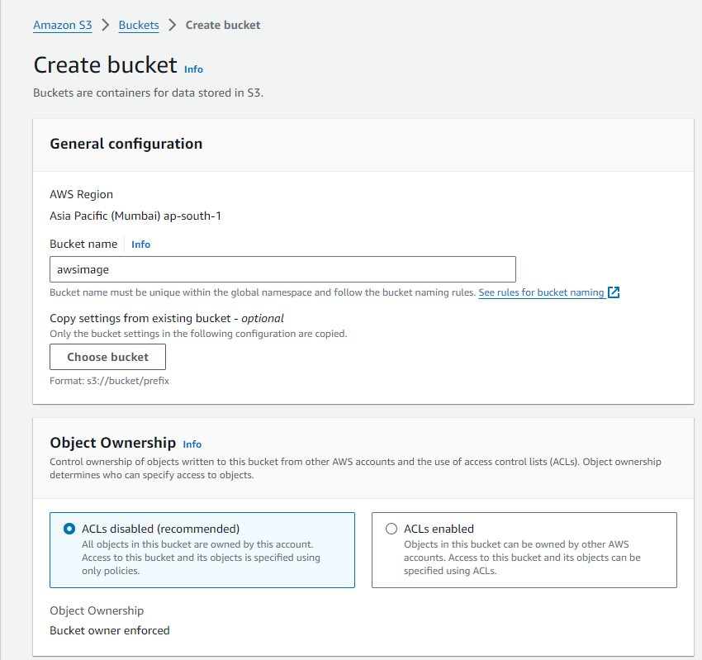

Block all the public access and disable bucket versoning.

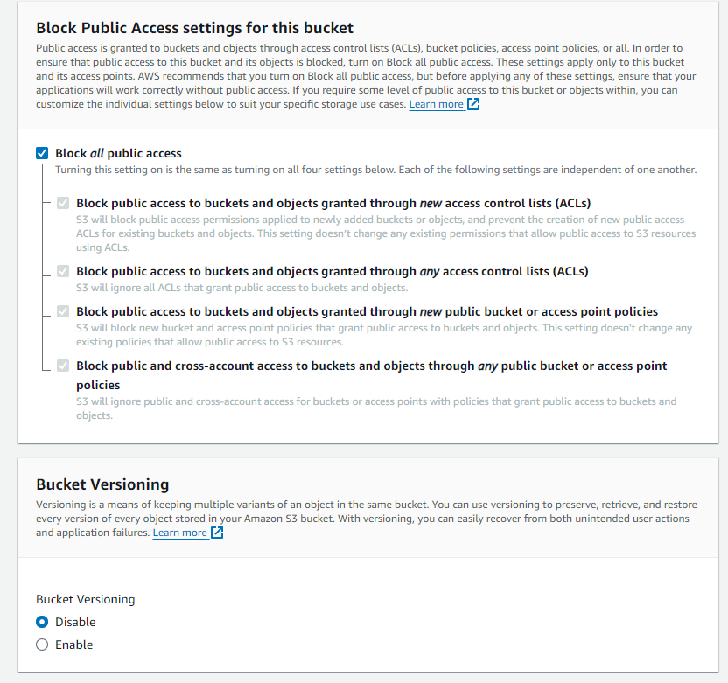

Follow the steps and select create bucket.

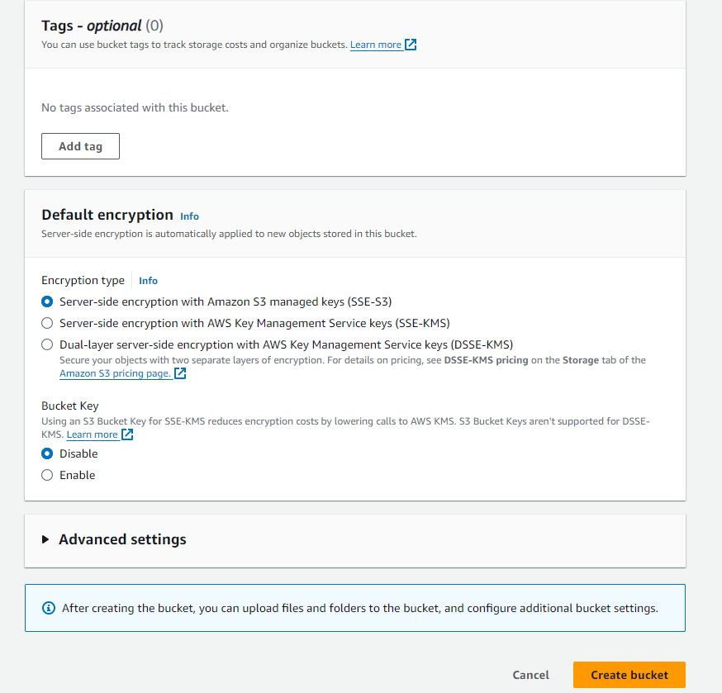

Create a folder inside the newly created bucket and then upload files in the folder.

Name the folder before uploading content into it.

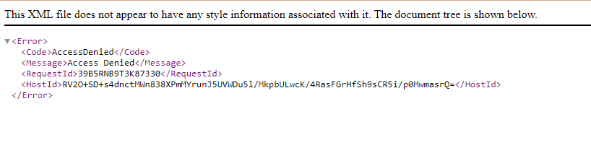

If we try to open the uploaded file directly from the link then it won’t open as we had blocked public access to it.

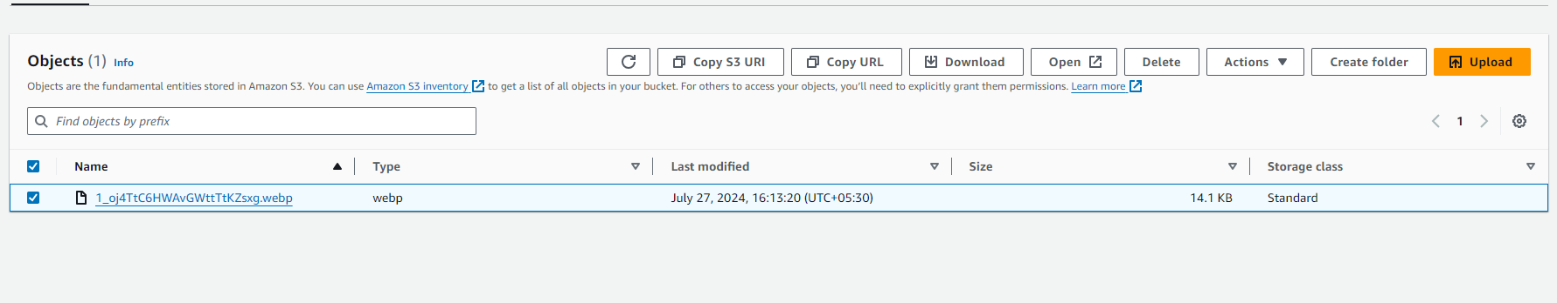

To open the uploaded file, select the file and choose open.



Implement S3 for uploading a static website.

Create a HTML code for static website and upload that file on S3 folder.